LMS Credit is a system feature used to manage and track the allocation of credits for course batches that require batch support credit. When a batch is set up to support credit, each learner’s participation in that batch consumes a specific number of LMS Credits. These credits are typically used to monitor course access, reward completion, or enable specific features within the Learning Management System. Proper tracking of LMS Credits ensures that batch resources are efficiently managed, prevents over-allocation, and provides insights into learner engagement and batch performance.
Buy Package Credit Selfpaced
- Go to https://agent-staging.cakap.com/campaign , choice type is offline.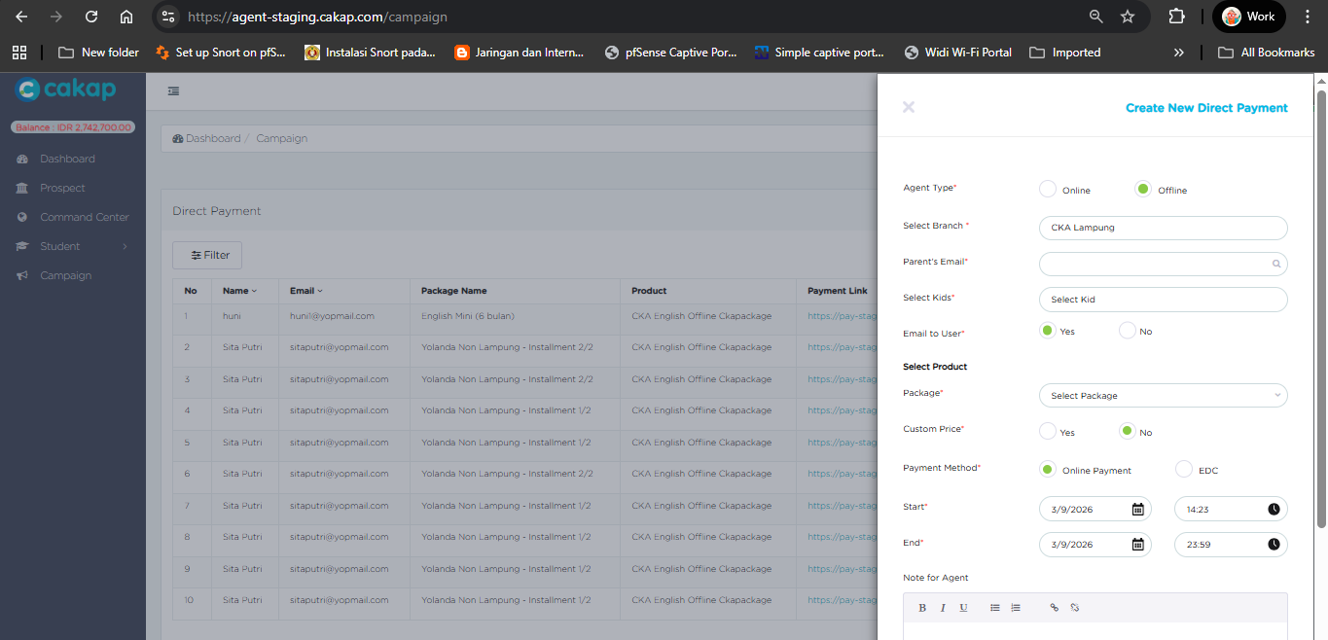
- Put email parent is has kids, after that select the kids.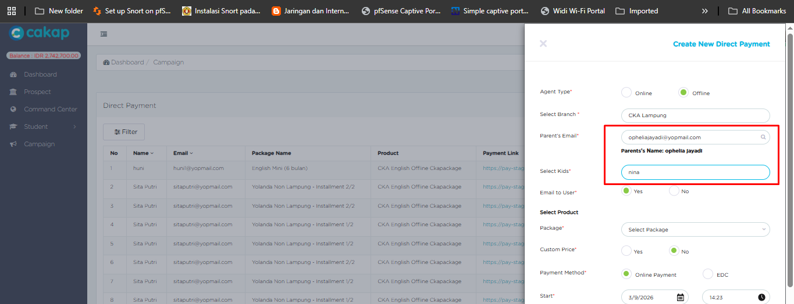
- Select package, choice payment method : Online Payment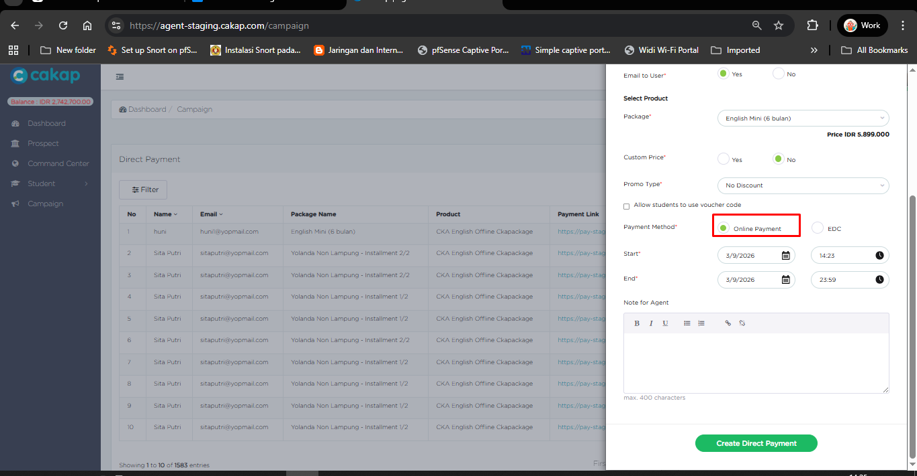
- After that create new payment, access the link is has been created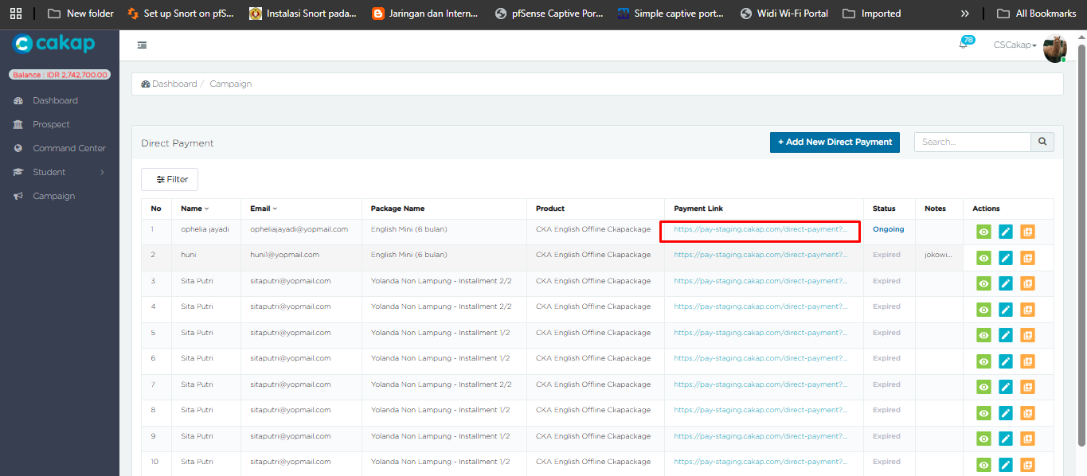
- Payment until paid, and student will get the credit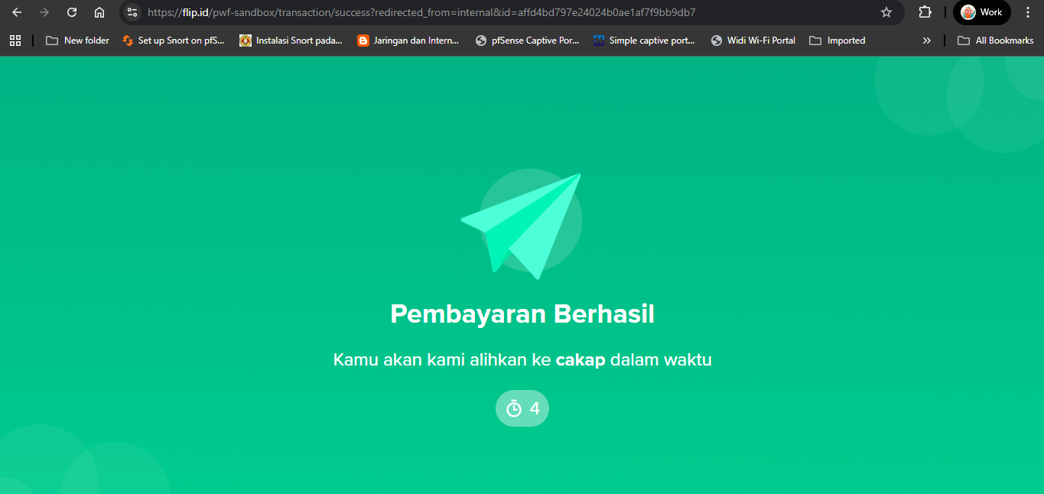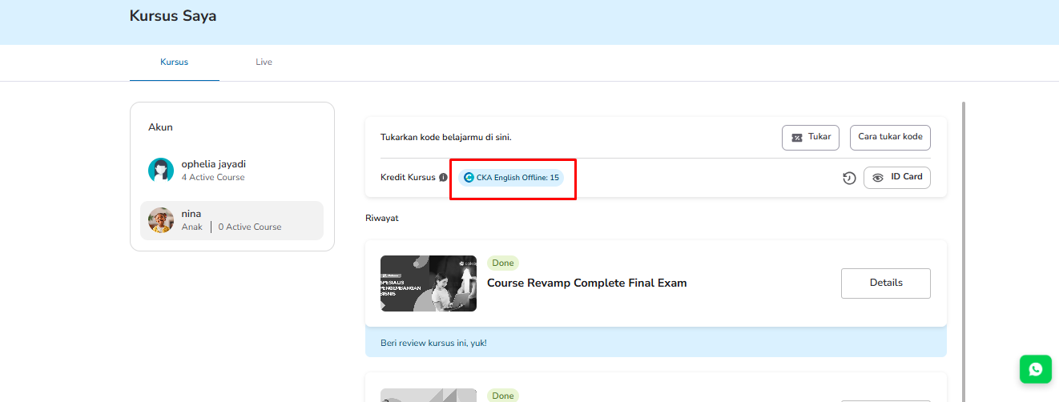

Student Redeem Course Credit
- Students can redeem a course in the LMS and get a code from the admin. Make sure the generated code for the course supports batch credit. Selfpaced Course Admin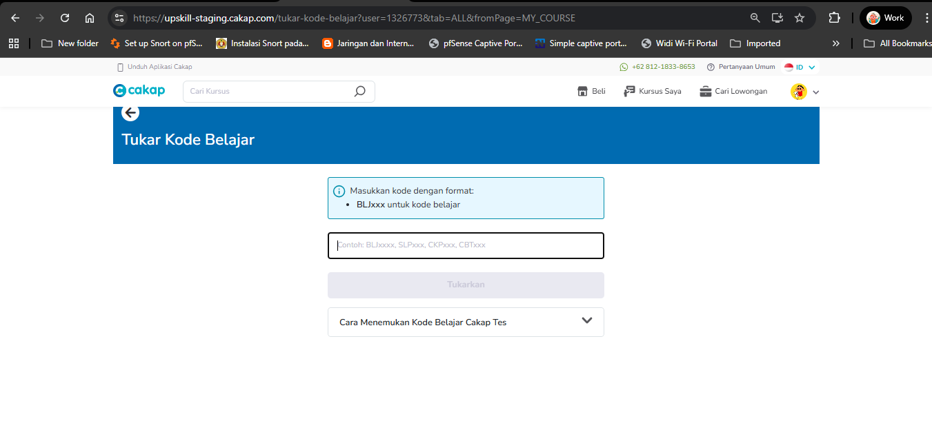
- Ensure that the student’s total credits are greater than or equal to the total course materials. If the credits are insufficient, the materials will be locked, and the student will need to purchase additional credits to complete the course.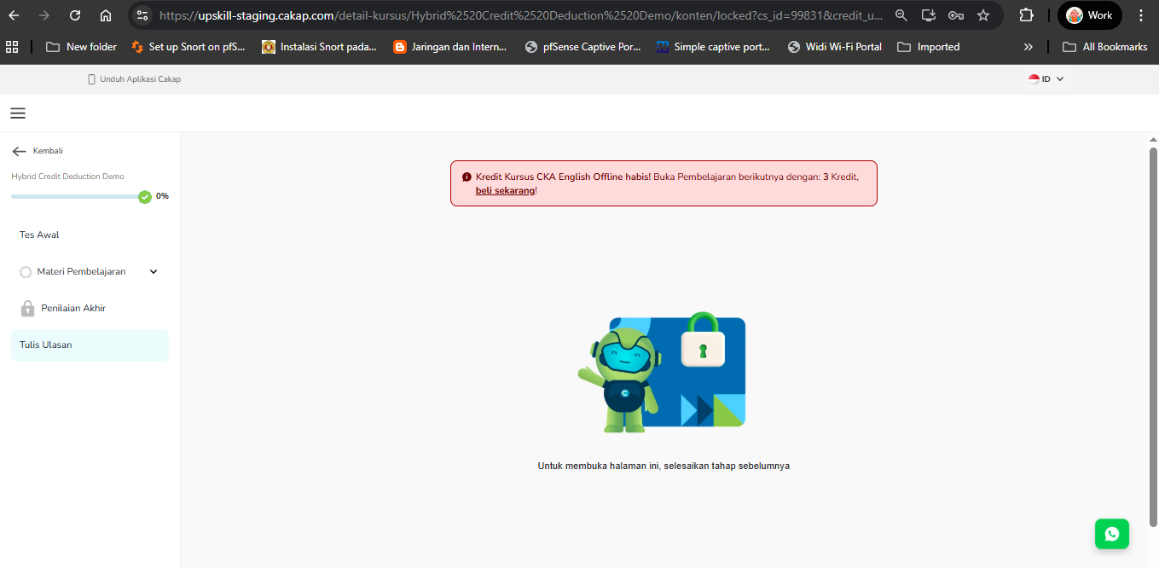

Admin Invite from Add Student Batch

- Go to menu batch -> Add students to batch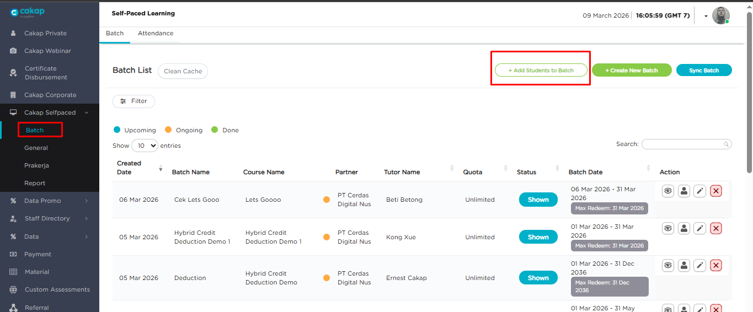
- Select the join date, then select the course and batch that support credits. Search for and select the parent’s email, and choose the corresponding child.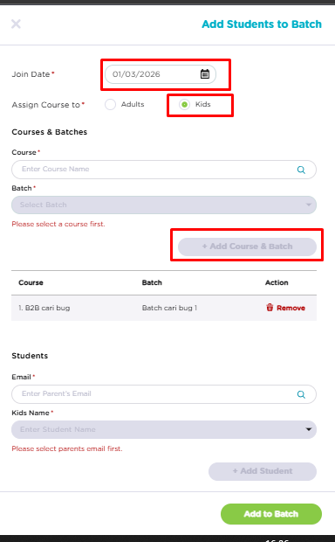
- Click Add to Batch to add the student to the batch.